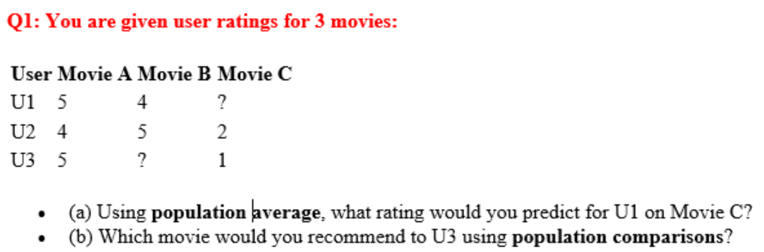

**Using Population Average:**

Recommendation system recommends data based on overall popularity or average rating across all users. It is calculating overall average of the product and then ranking them, then recommending the product to everyone. It is simpler and easier to implement but it is not personalized as it assumes everyone likes same things.

We have to calculate rating using C: (U2 = 1 + U3 = 2)/2 = 1.5

So the predicted rating for U1 on Movie C is 1.5 according to population average, and poor rating shows that movie should not be recommended.

**Using Population Comparisons:**

Instead of just taking average, compare how items perform relative to others in the population and rank them. It also takes rating distributions, popularity within specific groups and statistical measure in account. It is often better than plain averages because it considers relative performance and it can sometime rank items higher that have less but excellent reviews.

Movie A : (U1 = 5 + U2 = 4 + U3 = 5)/3 = 4.67

Movie B : (U1=4 + U2=5) / 2 = 4.5

Movie C: (U2=2 + U3=1) / 2 = 1.5

U3 has already rated Movie A (rating of **5**) and Movie C (rating of **1**). The movie U3 has not rated is Movie B, which has a population average of **4.5**.One thing to note here is while Movie A has complete data, Movie B, and C have missing data with makes it less effective.